**How to set out cardboard for pickup**

This reminder has been placed on all One-Sort recycling carts in the City. This **does not mean** that we found a problem with the contents of your cart.

**How to properly set out cardboard:**

• **Remove all packing materials and flatten boxes.**

• Boxes that do not fit in your recycling cart may be placed next to your recycling inside one large box or bundled together with string or twine.

• Don't bundle boxes using wire or tape.

• Keep bundles to less than 3' x 3' and under 40 pounds.

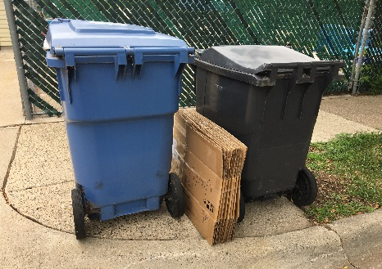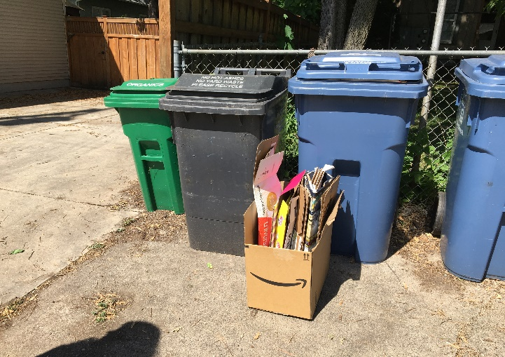

**Set-out cardboard should not look like:**

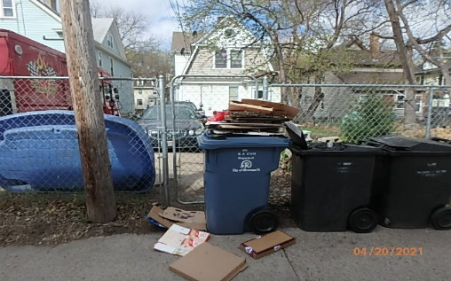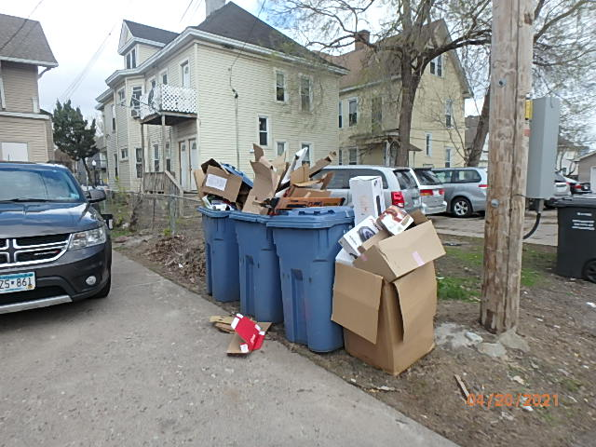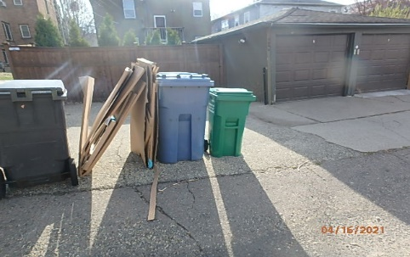

 Improperly prepared cardboard may not be collected. Thank you for your attention.

For more information call Solid Waste and Recycling at 612-673-2917,

email us at [SWRcustomer@minneapolismn.gov](mailto:SWRcustomer@minneapolismn.gov)

or visit [**minneapolismn.gov/recycling**](https://www.minneapolismn.gov/resident-services/garbage-recycling-cleanup/recycling/)

Hearing impaired can use a relay service to call 311 at 612-673-3000

TTY users call 612-263-6850